Hedwig and the angry inch. Origin Of Love Lyrics.

When the earth was still flat,
And the clouds made of fire,
And mountains stretched up to the sky,
Sometimes higher,
Folks roamed the earth
Like big rolling kegs.
They had two sets of arms.
They had two sets of legs.
They had two faces peering
Out of one giant head
So they could watch all around them
As they talked; while they read.
And they never knew nothing of love.
It was before the origin of love.
The origin of love
And there were (1)………. ………….then,
One that looked like two men
Glued up back to back,
Called the children of the sun.
And similar in shape and girth
Were the children of the earth.
They looked like two girls
Rolled up in one.
And the children of the moon
Were like a fork shoved on a spoon.
They were (2)…………………………
Part daughter, part son.
The origin of love
Now the gods grew quite scared
Of our strength and defiance
And Thor said,
"I'm gonna kill them all
With my hammer,
Like I killed the giants."
And Zeus said, "No,
You better let me
Use my lightening, like scissors,
Like I cut the legs off the whales
And dinosaurs into lizards."
Then he grabbed up some bolts
And he let out a laugh,
Said, "I'll split them right down the middle.
Gonna cut them right up in half."
And then storm clouds gathered above
Into great balls of fire
And then fire shot down
From the sky in bolts
Like shining blades
Of a knife.
And it ripped
Right through the flesh
Of the children of the sun
And the moon
And the earth.
And some Indian god
Sewed the wound up into a hole,
Pulled it round to our belly
To remind us of (3)……………...
And Osiris and the gods of the Nile
Gathered up a big storm
To blow a hurricane,
To scatter us away,
In a flood of wind and rain,
And a sea of tidal waves,
To wash us all away,
And if we don't behave
They'll cut us down again
And we'll be hopping round on one foot
And looking through one eye.
Last time I saw you
We had (4) …………………..
You were looking at me.
I was looking at you.
You had a way so familiar,
But I could not recognize,
Cause you had blood on your face;
I had blood in my eyes.
But I could swear by your expression
That the pain down (5)……………………
Was the same as the one down in mine.
That's the pain,
Cuts a straight line
Down through the heart;
We called it love.
So we wrapped our arms around each other,
Trying to shove ourselves back together.
We were making love,
Making love.
It was a cold dark evening,
Such a long time ago,
When by the mighty hand of Jove,
It was the sad story
How we became
Lonely (6)………………………,
It's the story of
The origin of love.
That's the origin of love.
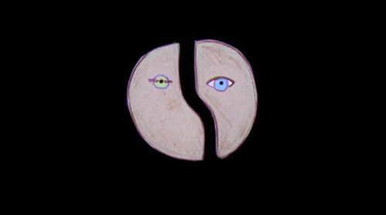
http://www.stlyrics.com/lyrics/hedwigandtheangryinch/originoflove.htm

