GROUP, NAME AND SURNAME:
SELFIES
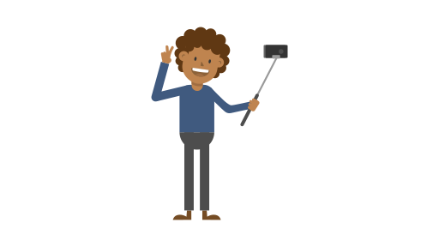
PLEASE ANSWER THE FOLLOWING QUESTIONS:
- WHAT IS YOUR OPINION ON SELF PHOTOGRAPHY (‘SELFIES’)?

- WHAT IS YOUR OPINION ON POSTING ‘SELFIES’ ON SOCIAL MEDIA (INSTAGRAM, SNAPCHAT, FACEBOOK AND TIKTOK)?

- DO YOU THINK SELFIES CAN EVER BE TAKEN AT A BAD TIME? E.G. DISRESPECTING A PERSON, PLACE, OR SITUATION. Give examples.
- BELOW YOU ARE GIVEN EXAMPLE SITUATIONS, PLEASE SPECIFY WHETHER YOU THINK THIS WOULD BE AN APPROPRIATE TIME TO TAKE A SELFIE…

YES = THIS IS A GOOD TIME / NO = THIS ISNT A GOOD TIME

It is graduation day and you have just graduated… YES / NO
Your friend has been arrested and you’re in the police station waiting for their release..YES /NO
There is a fight in a club, you aren’t involved but you think it’s a funny situation… YES / NO
You and some friends travel to the beach for a day and you decide to go swimming… YES / NO
It’s Saturday night and you’ve gone out for a nice meal… YES / NO
You’re Father has died and you’re at his funeral… YES / NO
A friend has drunk too much alcohol and has passed out… YES / NO
You’re at a war memorial paying tribute to hundreds of people that have died… YES / NO
- PLEASE CHOOSE A SITUATION YOU CIRCLED ‘NO’ FOR AND EXPLAIN WHY
- TAKE A LOOK TO THE PDF “CONCENTRATION CAMPS PICTURES”
PAY ATTENTION TO THE PHOTOGRAPHS THAT HAVE BEEN TAKEN AT THE WORLD WAR 2 DEATH CAMPS / MEMORIAL SITES AND PLEASE STATE YOUR OPINION BELOW
- WATCH THE FOLLOWING VIDEO: https://www.youtube.com/watch?v=mjjV_X5re4g
DO YOU THINK THE ‘YOLOCAUST’ BY WAS A JUSTIFIED REACTION OR AN OVERREACTION? EXPLAIN IT.

- VISIT THE FOLLOWING WEBSITE AND LOOK AT THE GENERAL PUBLICS REACTION TO ‘YOLOCAUST’ https://yolocaust.de/
EXPLAIN YOUR OPINION.

